HTML NOTES

HTML stands for Hyper Text Markup Language.

* It is used to design the web pages
* Or can create a complete website structure.
* It is the combination of Hypertext and markup Language, where hypertext are links which makes easy for us to travel from one webpage to another. And markups are the languages enclosed within the tags
* HTML basically consists of tags, attributes and hyperlinks which design the web page

HTML BASIC STRUCTURE OF A WEB PAGE

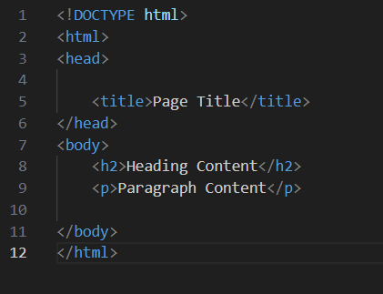

Paragraph tag

Heading tag

Body Tag

Title Tag

Head Tag

HTML root element

Tells version of HTML

Basic Tags

**<DOCTYPE! html>** – A doctype or document type declaration is an instruction that tells the web browser about the markup language in which the current page is written. It is not an element or tag. The doctype declaration is not case-sensitive.

**<html>** – This tag is used to define the root element of HTML document. This tag tells the browser that it is an HTML document. It is the second outer container element that contains all other elements within it.

**<head>** – This tag is used to define the head portion of the HTML document that contains information related to the document. Elements within the head tag are not visible on the front-end of a webpage.

**<body>** – The body tag is used to enclose all the visible content of a webpage. In other words, the body content is what the browser will show on the front end.

Example of simple HTML DOCUMENT:

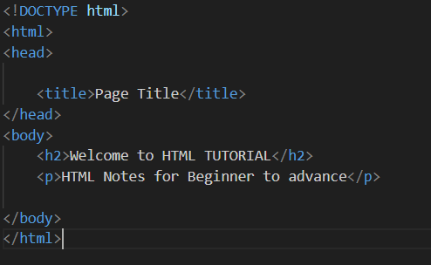

Output on webpage:

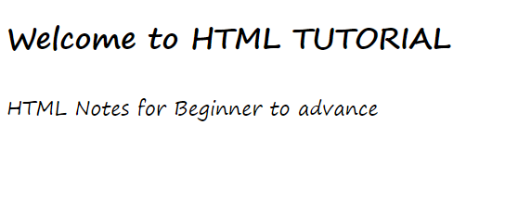

HTML TAGS

HTML tags are basically keywords that one can use to produce web pages.

So, there are two types of tags.

**Opening tags:** used at the opening of each statement

**<p>, <html>, <body>**

**Closing tags**: they contain a forward slash.

**</p>, </html>, </body>**

**HTML ELEMENTS**

The HTML element is everything from start to end tag:

Example:

<tagname>Content goes here...</tagname>

**Note:** YOU SHOULD NOT MISS THE END TAG.

Html elements are case sensitive.

**HTML ATTRIBUTES**

HTML attributes provide additional information about HTML elements.

* All HTML elements can have attributes
* Attributes provide additional information about elements
* Attributes are always specified in the start tag
* Attributes usually come in name/value pairs like: name="value"
* Example: image tag has src attribute for specifying path of image.

**HTML HEADINGS**

HTML headings are titles or subtitles that you want to display on a webpage.

HTML headings are defined with the <h1> to <h6> tags.

<h1> defines the most important heading. <h6> defines the least important heading.

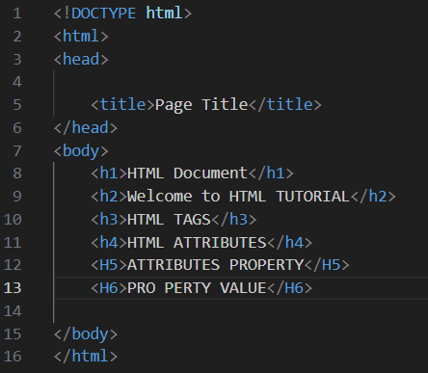

Output:

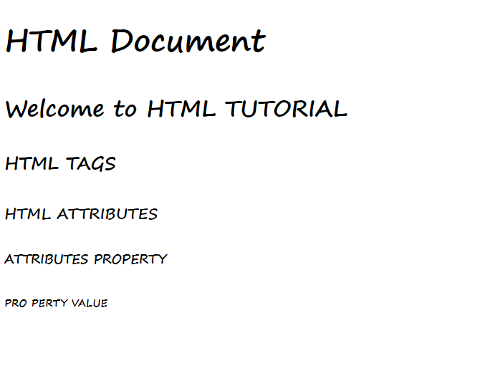

**What's in the head? Metadata in HTML**

The head of an HTML document is the part that is not displayed in the web browser when the page is loaded. It contains information such as the page <title>, links to CSS links to custom favicons, and other metadata.

Main elements that can be there in a HTML document:

1. Title: can be used to add title to the document.

Example:

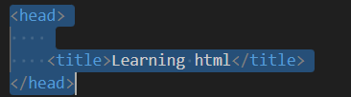

Output:

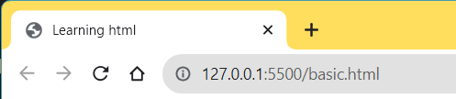

The <title> element contents are also used in other ways. For example, if you try bookmarking the page you will see the <title> contents filled in as the suggested bookmark name.

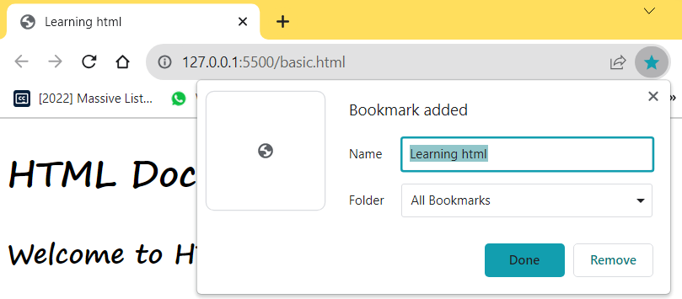

**Metadata: the <meta> element**

Metadata is data that describes data, and HTML has an "official" way of adding metadata to a document — the <meta> element. Of course, the other stuff we are talking about in this article could also be thought of as metadata too

Example:

<meta charset="utf-8">

This element specifies the document's character encoding — the character set that the document is permitted to use. utf-8 is a universal character set that includes pretty much any character from any human language. This means that your web page will be able to handle displaying any language; it's therefore a good idea to set this on every web page you create!

**Adding an author and description**

Many <meta> elements include name and content attributes:

name specifies the type of meta element it is; what type of information it contains.

content specifies the actual meta content.

 <meta name="author" content="himanshi-gupta"/>

**Applying CSS and JavaScript to HTML**

You can add CSS and JavaScript file in the head element of your file.

**Syntax to add a CSS file:**

<link rel=” stylesheet” href=” filename.css”/>

**Syntax to add a JS file:**

<script src=filename.JS defer></script>

defer,basically instructs the browser to load the JavaScript after the page has finished parsing the HTML.

**Setting the primary language of the document**

you can (and really should) set the language of your page.

<html lang="en-US">

# HTML text fundamentals

# One of HTML's main jobs is to give text structure so that a browser can display an HTML document the way its developer intends.

# Structured content makes the reading experience easier and more enjoyable.

# In HTML, each paragraph has to be wrapped in a <p> element, like so:

<P>this is a paragraph</P>

Each heading has to be wrapped in a heading element:

  <h1>this is a heading</h1>

There are six heading elements: h1, h2, h3, h4, h5, and h6.

**Lists**

HTML lists allow web developers to group a set of related items in lists.

List can be of two type ordered and unordered

**Ordered list:**

An ordered list starts with the <ol> tag. Each list item starts with the <li> tag.

Ordered lists are lists in which the order of the items does matter.

Example a list of instructions:

<ol>

        <li>take some flour.</li>

        <li>add milk to it</li>

        <li>and rest steps</li>

    </ol>

The ordered list uses the numbers as default to show the items:

Output for above example:

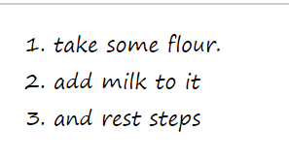

**Unordered list:**

An unordered list starts with the <ul> tag. Each list item starts with the <li> tag.

<ul>

        <li>potato</li>

         <li>garlic</li>

         <li>ginger</li>

    </ul>

Default way to represent elements:

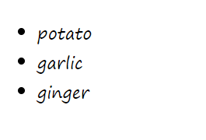

**DESCRIPTION LIST**

A description list is a list of terms, with a description of each term.

The <dl> tag defines the description list, the <dt> tag defines the term (name), and the <dd> tag describes each term:

<dl>

        <dd>coffee</dd>

        <dt>Black hot drink</dt>

        <dd>milk</dd>

        <dt>white drink</dt>

    </dl>

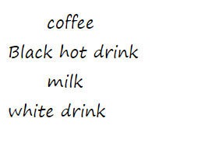

**HTML Formatting Elements**

Formatting elements were designed to display special types of text:

<b> - Bold text

<strong> - Important text

<i> - Italic text

<em> - Emphasized text

<mark> - Marked text

<small> - Smaller text

<del> - Deleted text

<ins> - Inserted text

<sub> - Subscript text

<sup> - Superscript text

<b>bold text</b>

    <strong>importent text</strong>

    <i>italic text</i>

    <em>emphasized text</em>

    <mark>marked text</mark>

    <small>smaller text</small>

    <del>deleted text</del>

    <ins>inserted text</ins>

    <sub>subscript text</sub>

    <sup>superscript text</sup>



HTML Quotation and Citation Elements

**HTML <blockquote> for Quotations**

The HTML <blockquote> element defines a section that is quoted from another source.

**HTML <q> for Short Quotations**

The HTML <q> tag defines a short quotation.

<q>build a future where people </q>

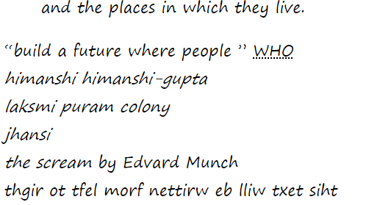

**HTML <abbr> for Abbreviations**

The HTML <abbr> tag defines an abbreviation or an acronym, like "HTML", "CSS", "Mr.", "Dr.", "ASAP", "ATM".

<abbr title="World Health Organization">WHO</abbr>



**HTML <address> for Contact Information**

The HTML <address> tag defines the contact information for the author/owner of a document or an article.

<address>

    himanshi himanshi-gupta<br>

    laksmi puram colony <br>

    jhansi<br>

</address>



**HTML <cite> for Work Title**

The HTML <cite> tag defines the title of a creative work (e.g. a book, a poem, a song, a movie, a painting, a sculpture, etc.).

<cite>the scream</cite> by Edvard Munch



**HTML <bdo> for Bi-Directional Override**

BDO stands for Bi-Directional Override.

The HTML <bdo> tag is used to override the current text direction

<bdo dir="rtl">this text will be written from left to right</bdo>



**HTML Comment Tag**

Comments in html can be added in following ways:

<!-- Write your comments here -->

**HTML COLORS**

HTML colors are specified with predefined color names, or with RGB, HEX, HSL, RGBA, or HSLA values.

<p style="background-color: rgb(104,75,00);">himanshi</p>

<p style="background-color: #ff6347;">himanshi</p>

<p style="background-color: hsl(9, 100%, 64%);">himanshi</p>

<p style="background-color: rgba(104,75,00,0.8);">himanshi</p>

<p style="background-color: hsla(1,100%,50%,0.5);">himanshi</p>

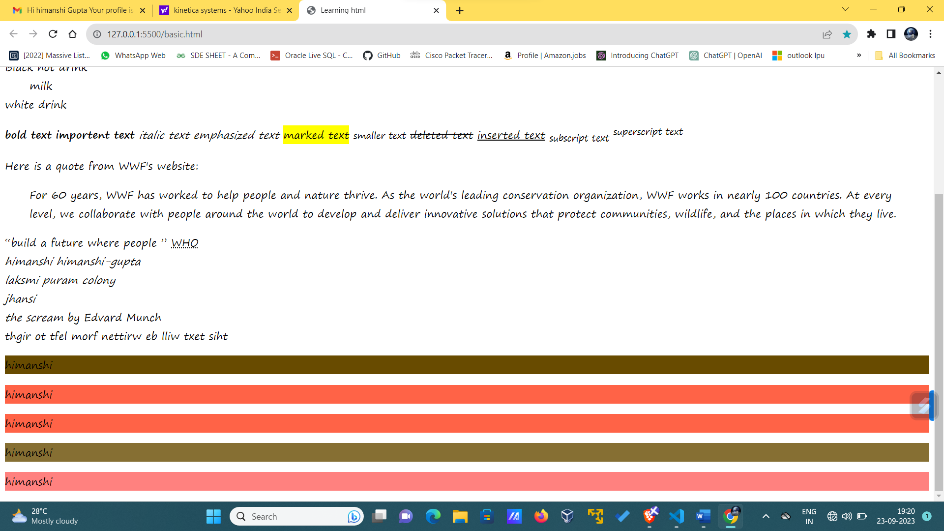

The a in the RGBA, and HSLA stands for alpha color

This is for transparency.

# HTML Links

Links are found in nearly all web pages. Links allow users to click their way from page to page.

HTML links are hyperlinks.

You can click on a link and jump to another document.

When you move the mouse over a link, the mouse arrow will turn into a little hand.

HTML LINK TAG: <a href=”url”>link text</a>

It is also known as anchor tag.

Here ‘a’ stands for anchor and href is the attribute for this tag which contains the link to destination.

Example:

<a href="objects.html">link</a>



By default, links will appear as follows in all browsers:

1. An unvisited link is underlined and blue
2. A visited link is underlined and purple
3. An active link is underlined and red

HTML Links - The target Attribute

By default, the linked page will be displayed in the current browser window. To change this, you must specify another target for the link.

The target attribute specifies where to open the linked document.

The target attribute can have one of the following values:

_self - Default. Opens the document in the same window/tab as it was clicked

_blank - Opens the document in a new window or tab

_parent - Opens the document in the parent frame

_top - Opens the document in the full body of the window

<a href="objects.html" target="_top">link</a>

**Absolute URLs vs. Relative URLs**

Both examples above are using an absolute URL (a full web address) in the href attribute.

A local link (a link to a page within the same website) is specified with a relative URL (without the "https://www" part):

Link to an Email Address

Use mailto: inside the href attribute to create a link that opens the user's email program (to let them send a new email)

<a href="mailto:himansi.07.gpt@gmail.com">send mail</a>

# HTML Links - Different Colors

# An HTML link is displayed in a different color depending on whether it has been visited, is unvisited, or is active.

# HTML Link Colors

# By default, a link will appear like this (in all browsers):

# An unvisited link is underlined and blue

# A visited link is underlined and purple

# An active link is underlined and red

We can change the link color and property by

Using the style tag in CSS.

<style>

        a:link{

            color: green;

            background-color: transparent;

            text-decoration: none;

        }

        a:visited{

            color: pink;

            background-color: transparent;

            text-decoration: none;}

        a:hover{

            color: red;

            background-color: transparent;

            text-decoration: underline;

        }

        a:active{

            color: yellow;

            background-color: transparent;

            text-decoration: underline;

        }

    </style>

# HTML Links - Create Bookmarks

HTML links can be used to create bookmarks, so that readers can jump to specific parts of a web page.

**Create a Bookmark in HTML**

Bookmarks can be useful if a web page is very long.

To create a bookmark - first create the bookmark, then add a link to it.

When the link is clicked, the page will scroll down or up to the location with the bookmark.

<h2 id="C4">Chapter 4</h2>

<a href="#C4">jump to chapter 4</a>

HTML images syntax

Image tag in html are used to add images to your html document.

Syntax:

<Img src=path of the image />

The <img> tag attributes:

src - Specifies the path to the image

alt - Specifies an alternate text for the image

height – specifies the height of the image

width – specifies the width of the image

common image extensions which are supported

APNG, GIF, ICO, JPEG, PNG, JPEG

# HTML Image Maps

With HTML image maps, you can create clickable areas on an image.

<img src="workplace.jpg" alt="Workplace" usemap="#workmap">

<map name="workmap">

<area shape="rect" coords="34,44,270,350" alt="Computer" href="computer.htm">

<area shape="rect" coords="290,172,333,250" alt="Phone" href="phone.htm">

<area shape="circle" coords="337,300,44" alt="Coffee" href="coffee.htm">

</map>

We can use image maps while showing maps (country, world maps) to click on a particular country and see information about that country.

# HTML <picture> Element

The HTML <picture> element allows you to display different pictures for different devices or screen sizes.

<picture>

<source media="(min-width: 650px)" srcset="img_food.jpg">

<source media="(min-width: 465px)" srcset="img_car.jpg">

<img src="img_girl.jpg">

</picture>

# HTML Tables

HTML tables allow web developers to arrange data into rows and columns.

Tags to define an HTML table:

<table>: used at the starting of the table

<td>: stands for table data

<tr>: stands for table row

<th>: stands for table headers

By default, the text in <th> elements are bold and centered, but you can change that with CSS.

Html table tags

Caption: defines a table caption

<tfoot> Groups the footer content in a table

<tbody> Groups the body content in a table

<thead> Groups the header content in a table

<col> Specifies column properties for each column within a <colgroup> element

<colgroup> Specifies a group of one or more columns in a table for formatting

<caption>students list</caption>

        <tr>

            <th>name</th>

            <th>age</th>

            <th>organisation</th>

        </tr>

        <tr>

            <td>himanshi</td>

            <td>20</td>

            <td>XYZ UNIVERSITY</td>

        </tr>

        <tr>

            <td>gupta</td>

            <td>20</td>

            <td>abc UNIVERSITY</td>

        </tr>

</table>

Output:

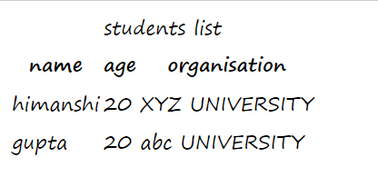

Adding border to the table

Border to a table can be added using border style property

 <table border="1px solid">

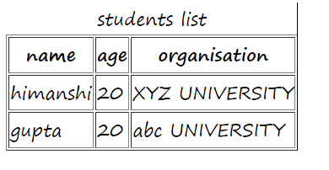

Border property and their values

1. Border collapse: To avoid having double borders like in the example above, set the CSS border-collapse property to collapse.
2. Border-radius: With the border-radius property, the borders get rounded corners
3. Border style: With the border-style property, you can set the appearance of the border.
4. Border-color: With the border-color property, you can set the color of the border.

# HTML Table Padding & Spacing

HTML tables can adjust the padding inside the cells, and also the space between the cells.

With padding:

 th,td{

            padding: 15px;

        }

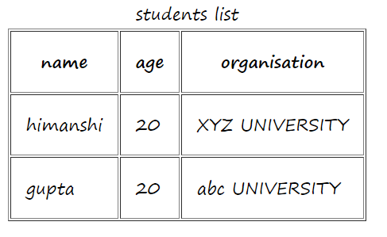

With spacing:

table{

          border-spacing: 30px;

        }

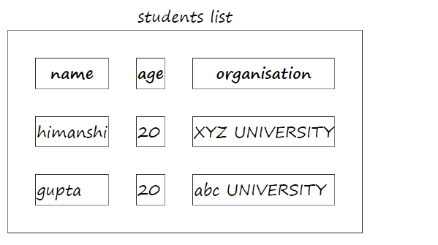

# HTML Table Colspan & Rowspan

To make a cell span over multiple columns, use the colspan attribute:

 <tr>

            <th colspan="2">name</th>

            <th>age</th>

            <th>organisation</th>

        </tr>

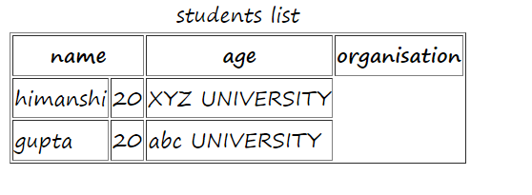

Rowspan: To make a cell span over multiple rows, use the rowspan attribute:

 <tr>

            <td rowspan="2">himanshi</td>

            <td>20</td>

            <td>XYZ UNIVERSITY</td>

        </tr>

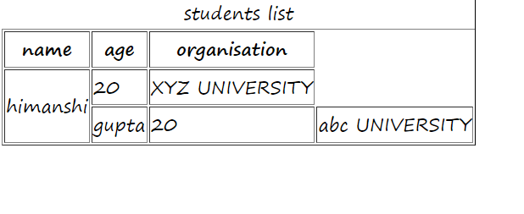

The <colgroup> element is used to style specific columns of a table.

<table>

<colgroup>

<col span="2" style="background-color: #D6EEEE">

</colgroup>

<tr>

<th>MON</th>

<th>TUE</th>

<th>WED</th>

<th>THU</th>

# HTML Block and Inline Elements

Every HTML element has a default display value, depending on what type of element it is.

There are two display values: block and inline.

**Block-level Elements**

A block-level element always starts on a new line, and the browsers automatically add some space (a margin) before and after the element.

A block-level element always takes up the full width available (stretches out to the left and right as far as it can).

Two commonly used block elements are: <p> and <div>.

The <p> element defines a paragraph in an HTML document.

The <div> element defines a division or a section in an HTML document.

<p>Hello World</p>

<div>Hello World</div>

**Inline Elements**

An inline element does not start on a new line.

An inline element only takes up as much width as necessary.

Span is an inline element.

# HTML Iframes

# An HTML iframe is used to display a web page within a web page.

<iframe src="basic.html" title="basics of html" height="100px" width="100px"></iframe>

# Iframe - Target for a Link

# An iframe can be used as the target frame for a link.

# The target attribute of the link must refer to the name attribute of the iframe:

# Example

# <iframe src="demo_iframe.htm" name="iframe_a" title="Iframe Example"></iframe>

# <p><a href="https://www.w3schools.com" target="iframe_a">W3Schools.com</a></p>

# HTML File Paths

# Absolute File Paths

# An absolute file path is the full URL to a file

# Relative File Paths

# A relative file path points to a file relative to the current page

# HTML Layout Techniques

# There are four different techniques to create multicolumn layouts. Each technique has its pros and cons:

# CSS framework

# CSS float property

# CSS flexbox

# CSS grid

# HTML <kbd> For Keyboard Input

# The HTML <kbd> element is used to define keyboard input. The content inside is displayed in the browser's default monospace font.

<kbd>ctrl + S</kbd>

## **HTML <code> For Computer Code**

The HTML <code> element is used to define a piece of computer code. The content inside is displayed in the browser's default monospace font.

<code>

    x=9;

    y=10;

    z=x+y;

</code>

## **HTML <var> For Variables**

The HTML <var> element is used to define a variable in programming or in a mathematical expression. The content inside is typically displayed in italic.

<var>h</var>

# HTML Forms

An HTML form is used to collect user input. The user input is most often sent to a server for processing.

# The <form> Element

# The HTML <form> element is used to create an HTML form for user input:

# The <input> Element

# The HTML <input> element is the most used form element.

# An <input> element can be displayed in many ways, depending on the type attribute.

<form>

        <label for="fname">First Name:</label>

        <input type="text" id="fname" name="fname" placeholder="fname"><br>

        <label for="lname">Last Name:</label>

        <input type="text" id="lname" name="lname" placeholder="lname"><br>

        <input type="radio" id="html" name="fav" value="html">

        <label for="html">HTML</label>

        <input type="radio" id="css" name="fav" value="css">

        <label for="css">CSS</label>

        <input type="radio" id="JS" name="fav" value="JS">

        <label for="JS">JAVASCRIPT</label>

        <br>

        <input type="CHECKBOX" id="bike" name="vehicle" value="bike">

        <label for="bike">I HAVE A BIKE</label>

        <br>

        <input type="CHECKBOX" id="car" name="vehicle" value="car">

        <label for="car">I HAVE A CAR</label>

        <br>

        <input type="CHECKBOX" id="scooty" name="vehicle" value="scooty">

        <label for="scooty">I HAVE A scooty</label>

        <input type="submit" value="submit">

# ‘

# The Action Attribute

# The action attribute defines the action to be performed when the form is submitted.

# Usually, the form data is sent to a file on the server when the user clicks on the submit button.

# <form action="/action_page.php">

# The Target Attribute

# The target attribute specifies where to display the response that is received after submitting the form.

# The target attribute can have one of the following values:

# Value Description

# _blank The response is displayed in a new window or tab

# _self The response is displayed in the current window

# _parent The response is displayed in the parent frame

# _top The response is displayed in the full body of the window

# framename The response is displayed in a named iframe

# The Method Attribute

# The method attribute specifies the HTTP method to be used when submitting the form data.

# The form-data can be sent as URL variables (with method="get") or as HTTP post transaction (with method="post").

# The Autocomplete Attribute

# The autocomplete attribute specifies whether a form should have autocomplete on or off.

# When autocomplete is on, the browser automatically complete values based on values that the user has entered before.

# <form action="/action_page.php" autocomplete="on">

# The Novalidate Attribute

# The novalidate attribute is a boolean attribute.

# When present, it specifies that the form-data (input) should not be validated when submitted.

# <form action="/action_page.php" novalidate>

# The <select> Element

# The <select> element defines a drop-down list:

<select id="cars" name="cars" size="2">

            <option value="volvo">VOLVO</option>

            <option value="volvo">fiat</option>

            <option value="volvo">audi</option>

        </select>

# The <textarea> Element

# The <textarea> element defines a multi-line input field (a text area):

# <textarea name="message" rows="10" cols="30">

# The cat was playing in the garden.

# </textarea>

# The <fieldset> and <legend> Elements

# The <fieldset> element is used to group related data in a form.

# The <legend> element defines a caption for the <fieldset> element.

<fieldset>

        <legend>

            personlia:

        </legend>

        <form>

        </form>

    </fieldset>

# The <datalist> Element

# The <datalist> element specifies a list of pre-defined options for an <input> element.

# Users will see a drop-down list of the pre-defined options as they input data.

# The list attribute of the <input> element, must refer to the id attribute of the <datalist> element.

<input list="browsers">

    <datalist id="browsers">

        <option value="1">

            <option value="2">

                <option value="3">

    </datalist>

# HTML Input Types

# <input type="button">

# <input type="checkbox">

# <input type="color">

# <input type="date">

# <input type="datetime-local">

# <input type="email">

# <input type="file">

# <input type="hidden">

# <input type="image">

# <input type="month">

# <input type="number">

# <input type="password">

# <input type="radio">

# <input type="range">

# <input type="reset">

# <input type="search">

# <input type="submit">

# <input type="tel">

# <input type="text">

# <input type="time">

# <input type="url">

# <input type="week">

# Readonly: The input readonly attribute specifies that an input field is read-only.

# Disabled: The input disabled attribute specifies that an input field should be disabled.